**SOFTWARE ENGINEERING (CSA0172)**

**DAY 2 PROBLEMS (17 AUG 2023)**

ATM MANAGEMENT SYSTEM

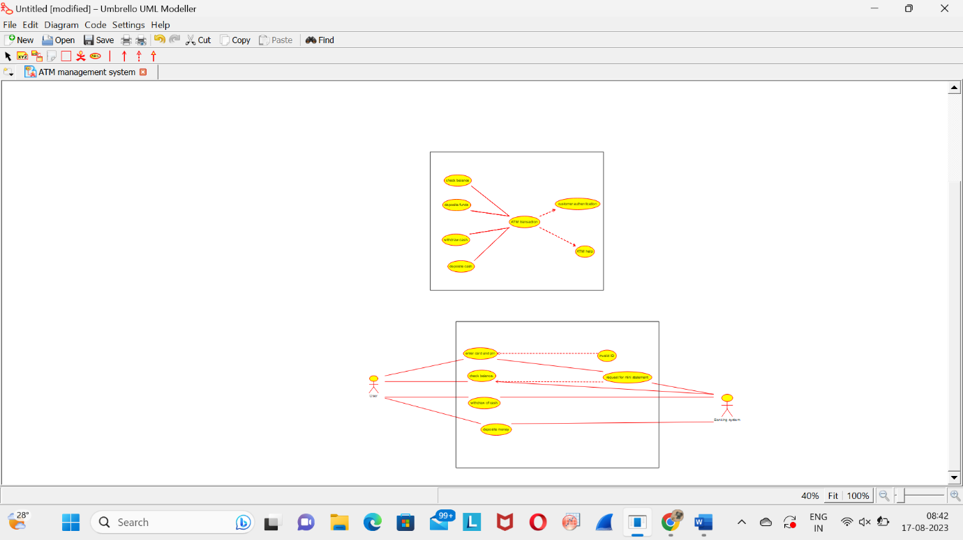

COLLEGE MANAGEMENT SYSTEM

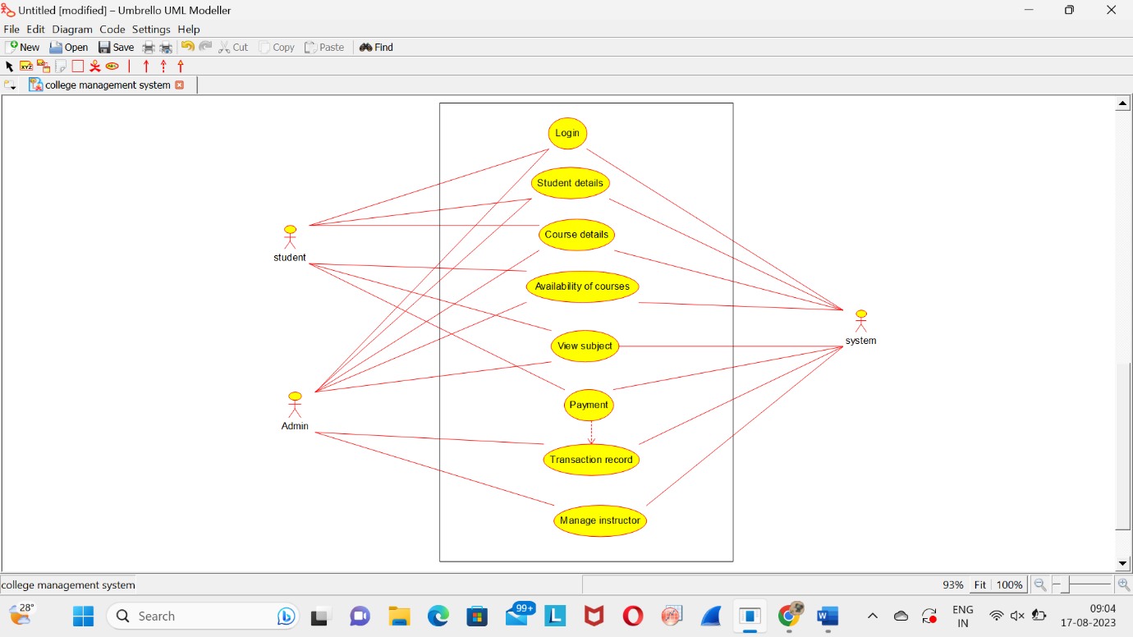

ONLINE VOTING SYSTEM (CLASS DIAGRAM)

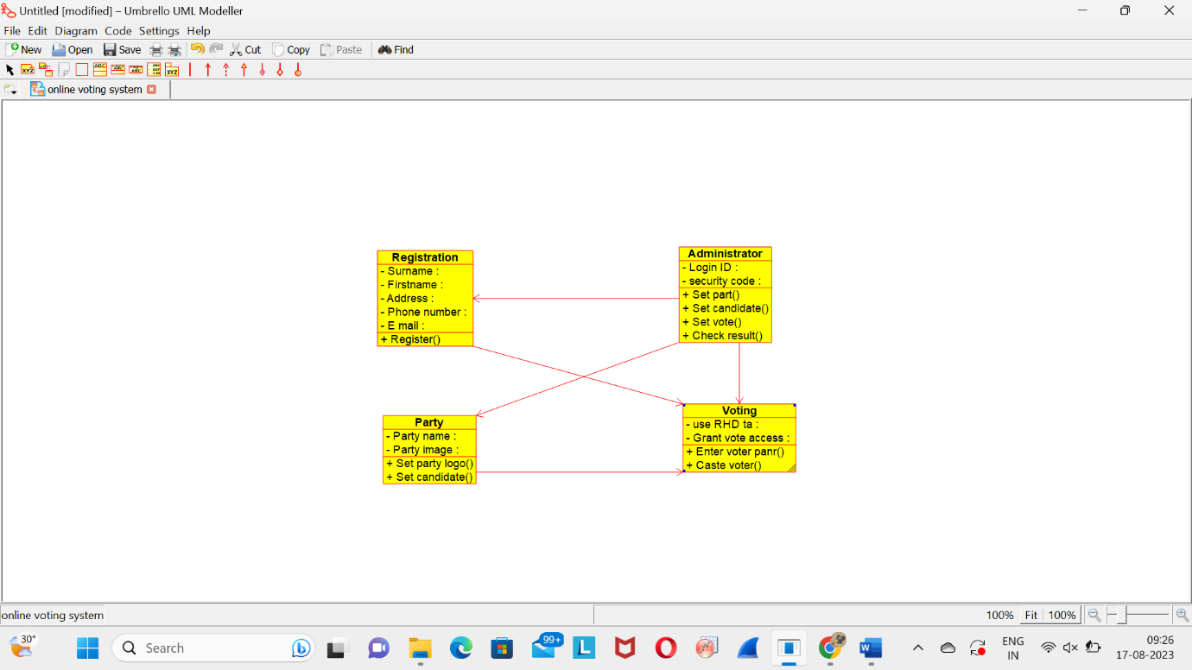

ONLINE VOTING SYSTEM (ACTIVITY DIAGRAM)

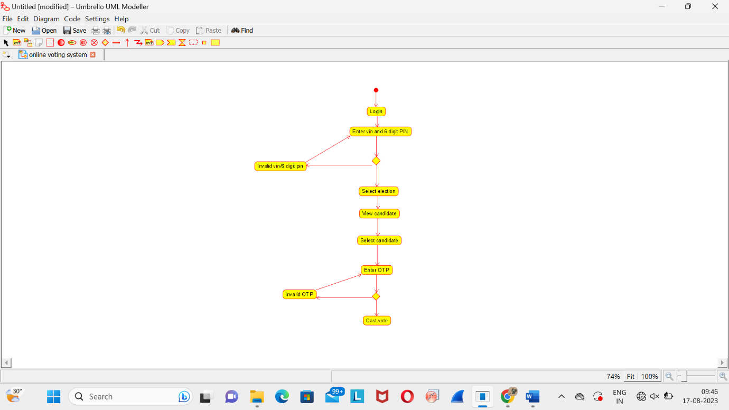

LIBRARY MANAGEMENT SYSTEM (ACTIVITY DIAGRAM)

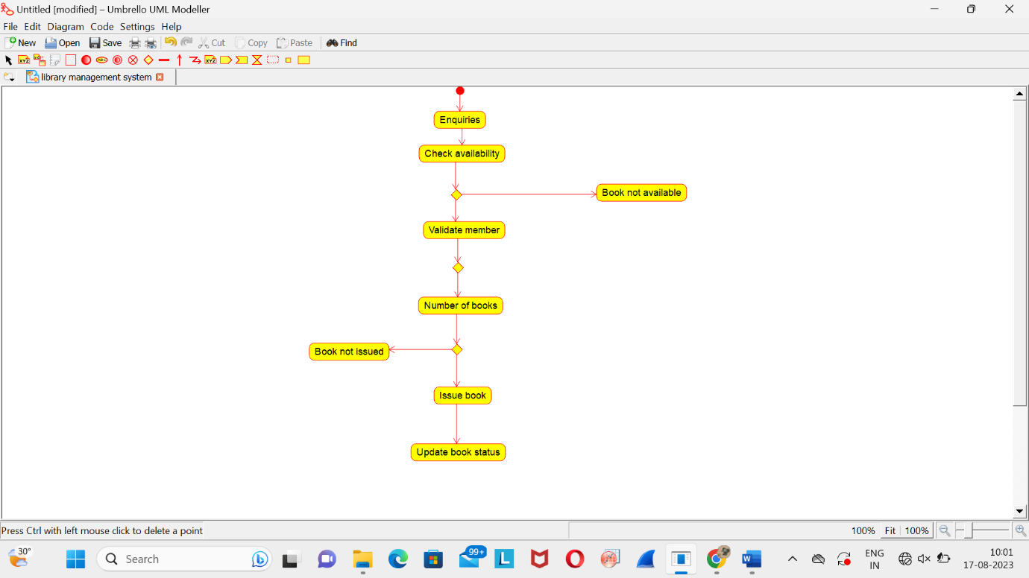

ONLINE SHOPING SYSTEM (ACTIVITY DIAGRAM)

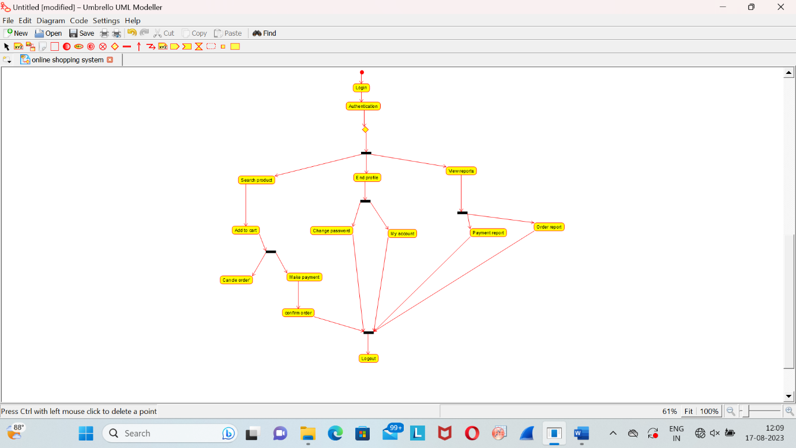

ONLINE RAILWAY RESERVATION SYSTEM (ACTVITY DIAGRAM)

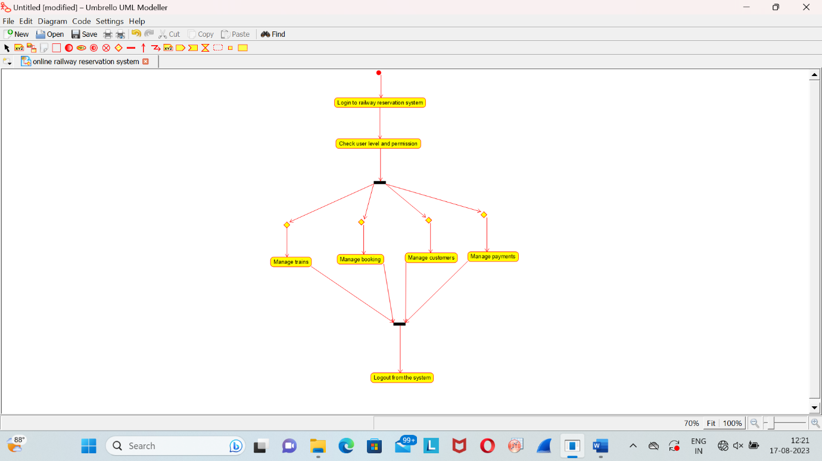

HOSPITAL MANAGEMENT SYSTEM (ACTIVITY DIAGRAM)

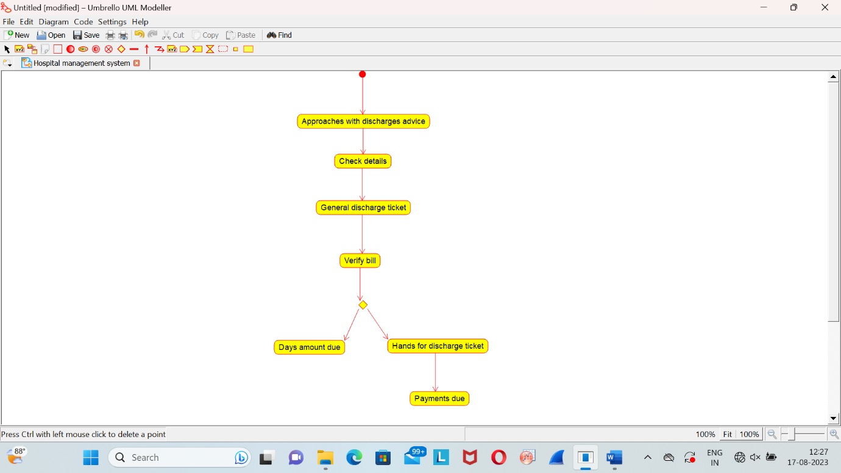

AUTOMATED ONLINE BANKING SYSTEM (ACTIVITY DIAGRAM)

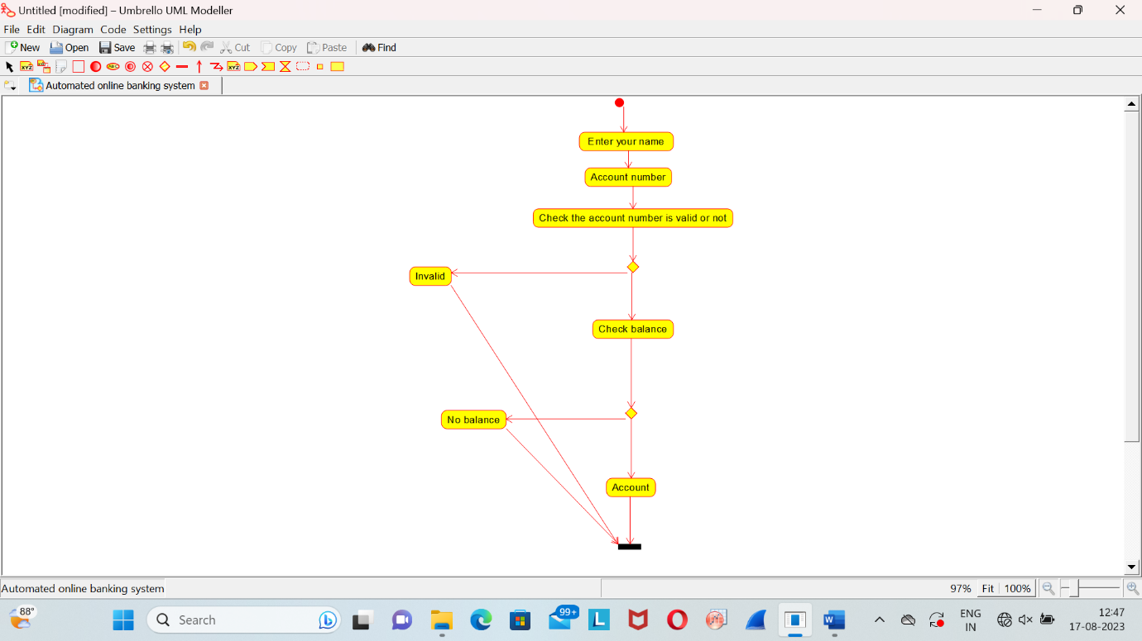

E-LIBRARY SYSTEM (CLASS DIAGRAM)

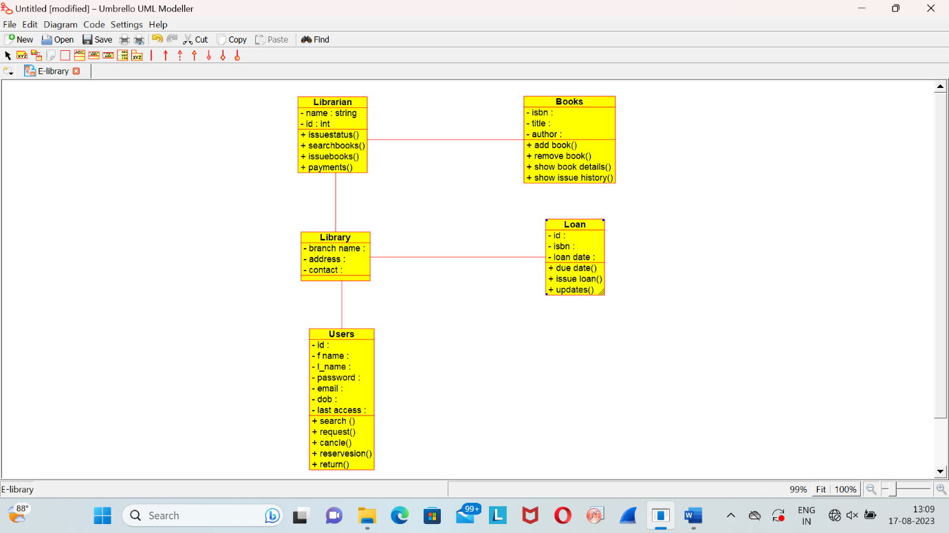

RESTAURANT SYSTEM (USE-CASE DIAGRAM)

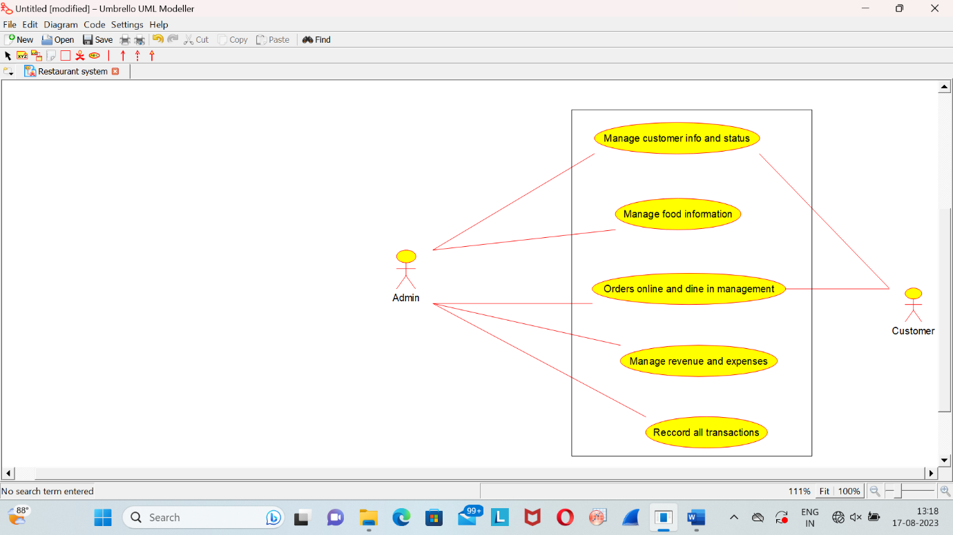

RESTAURANT SYSTEM (CLASS DIAGRAM)

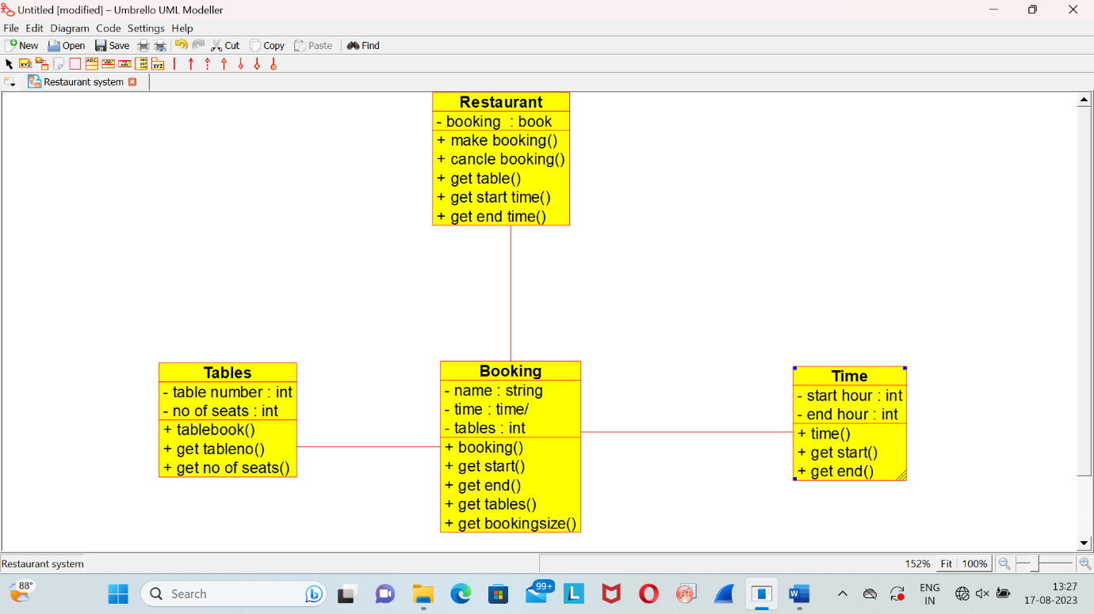

QUIZ SYSTEM (CLASS DIAGRAM)

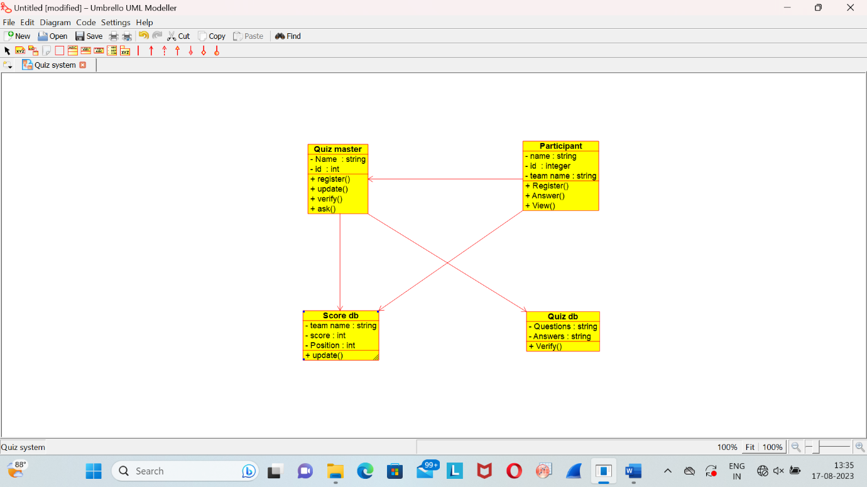

QUIZ SYSTEM (USE-CASE DIAGRAM)

